On your server go to the Updates folder. The Updates folder may be found by running EmpowerSupport and clicking on the Settings – Locations link.

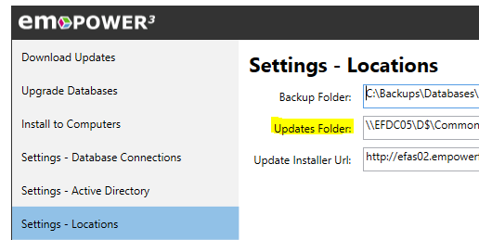

Using File Explorer, log into our ftp site: ftp.empowerfin.com

You are prompted for login credentials. Use your EmpowerSupport username and password to log into the FTP site.

You will see a folder labeled v2.2.xxx.0 where xxx is version that you need to install. The folder will contain the following files:

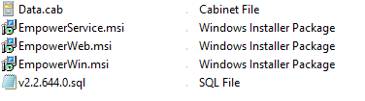
The SQL file will have the same version number as the folder itself.

Download the folder placing it into the Empower Updates folder.

Close down the File Explorer for the FTP site.

Copy the empower.config file from your previously numbered v2.2.xxx.0 folder to the current v2.2.xxx.0 folder.

When no users are working in Empower, open SQL Server Management Studio and run the SQL script from the v2.2.xxx.0 folder against each of your Empower databases.

If you upgrade the database while users are running EmpowerWin, the users’ EmpowerWin application will shut down, telling them the database is being upgraded, and the users will lose their unsaved work.
If EmpowerWin is installed on the server, run the EmpowerWin.msi from the v2.2.xxx.0 folder to install the current version of EmpowerWin. This is especially important if the EmpowerService is a service running on your server. The EmpowerService can run only if the latest version of EmpowerWin is installed on the server.

Go to Windows Services. If the EmpowerService is installed and is stopped, start it. If the Empower Support service is stopped, start it.

Once the above is completed, when a user logs into EmpowerWin, EmpowerWin asks them if they would like to upgrade. When they respond Yes, the EmpowerWin application uses the Empower Support service running on the server to run the .msi/data cab files put on your server on their workstation using the version number you just updated in the database and the folder you just downloaded (v2.2.xxx.0) to your server.

Contact Terri Hutter at Empower Financials for support at 734-747-9393, ext. 0, or t_hutter@empowerfin.com if you need help.

